**Building the Stallion VTOL airframe**

**Tips, Tricks & Notes**

**(work in progress)**

**Start:**

The Stallion airframe is largely made of a pre-foamed or active foaming PLA and requires you to tune flowrate, temperature, layer height, etc to get consistent print results. I found that the only real way to accomplish this was by trial and error. It was helpful to read and learn how the forementioned constraints affect the reliability and strength of your prints. Flightory recommends using Cura Slicer and provides some parameters settings for each filament.

I decided to use Prusa Slicer because of my past experience with it and because I used a Prusa Mini+ running firmware Ver. 6.2.0.

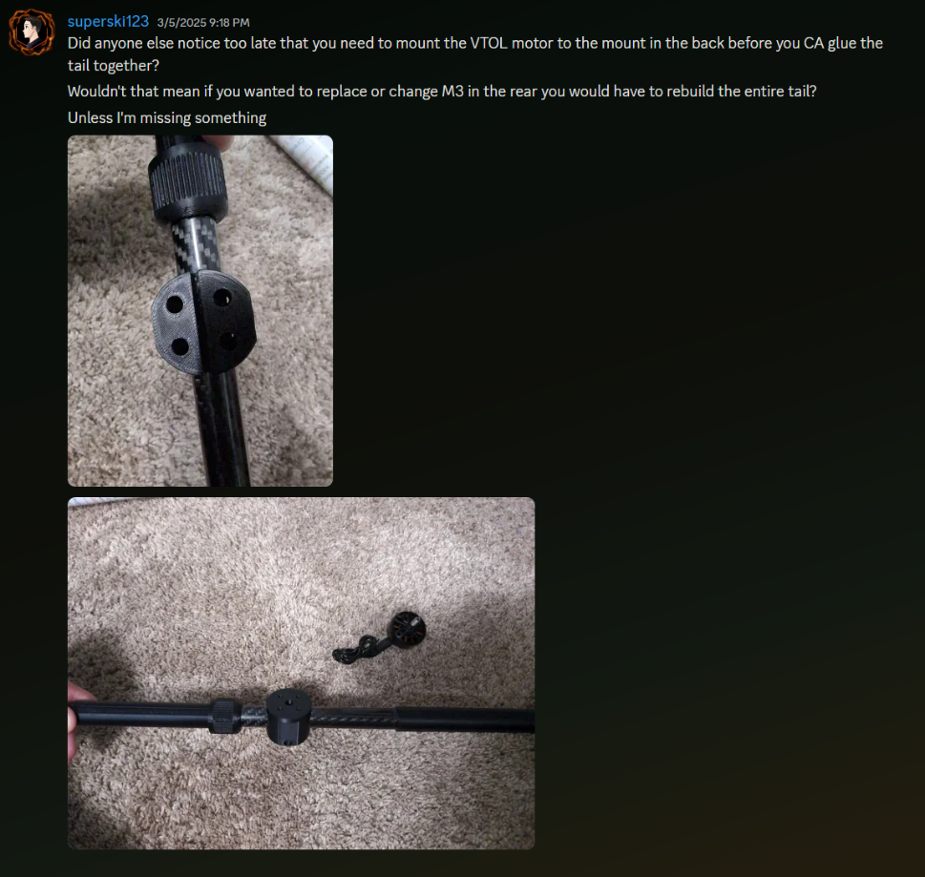Things to note:

Turning on brim to increase print bed adhesion

Use natural supports to save time and filament

Do not glue back of tail on before you put on motor mount

